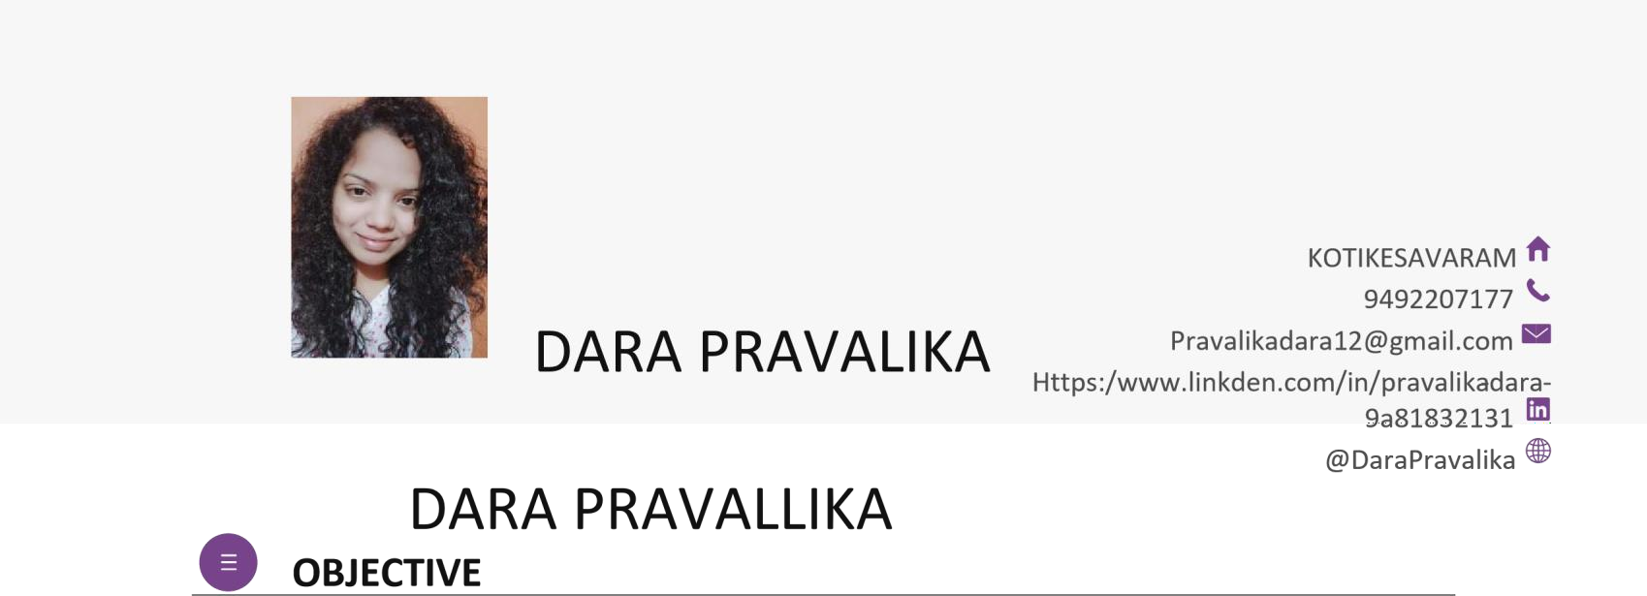



Seeking for good job and secure a better position where I can efficiently contribute my skills and abilities for the growth of the organization and my professional career. the word of my strength Are learn something from everyone and do something for everyone.

# EDUCATION

**B.Tech | INTERNATIONAL SCHOOL OF TECHNOLOGY AND SCIENCE FOR WOME’S**

**ENGINEERING COLLEGE 2018– 2022 PERCENTAGE:80%**

**BRANCH:COMPUTER SCIENCE AND ENGINEERING UNIVERSITY:JNTUK**

**INTERMEDIATE | A.P.S.W.E.R COLLEGE VEERALANKAPALL 2016-2018**

**PERCENTAGE:87% BRANCH:MPC**

**SSC:A.P.S.W.E.R COLLEGE VEERALANKAPALLI 2016**

**PERCENTAGE:90%**



# PEARSONAL INFORMATION

**Name : Pravalika Father’s name : Tammaya**

**Date of birth : 18/03/2001 Nationality : India**



**Languages know : Telugu,English**

**Hobbies : Reading books ,Singing,Browsing**

# SKILLS

* c language • html
* python
* **C++**
* SQL

**PROJECT**

# Registration form in html

* + **Pretty parlour website**

**DECLARATION**

I I do here by the declare that the particular of information and facts started herein above are true, correct and to the best of my knowledge

PLACE:Rajahmundry DATE:19/08/2021

(Dara Pravalika)